GitHub:
https://github.com/MansoorAZafar/fragments
Full CI Link
https://github.com/MansoorAZafar/fragments/actions/runs/14289641453
Lab 10 Hurl Link
https://github.com/MansoorAZafar/fragments/blob/main/tests/integration/lab-10-dynamodb.hurl

lab-10-dynamodb.hurl passing against Server & LocalStack
Against Local-Stack (im using a ./make.sh file to run the commands easily, it is provided below)
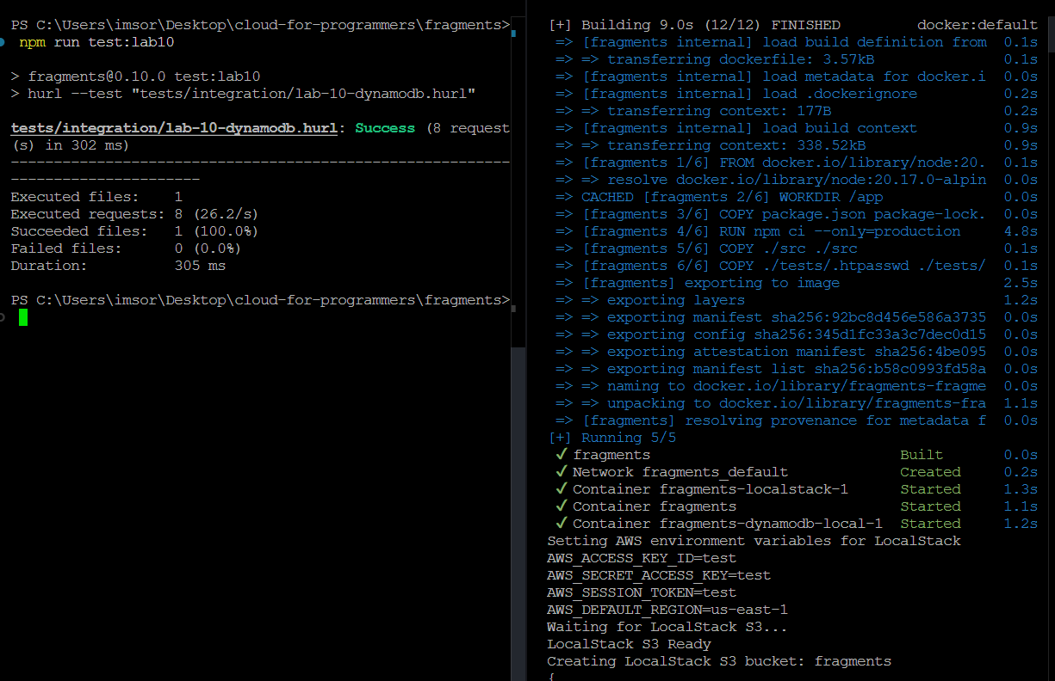
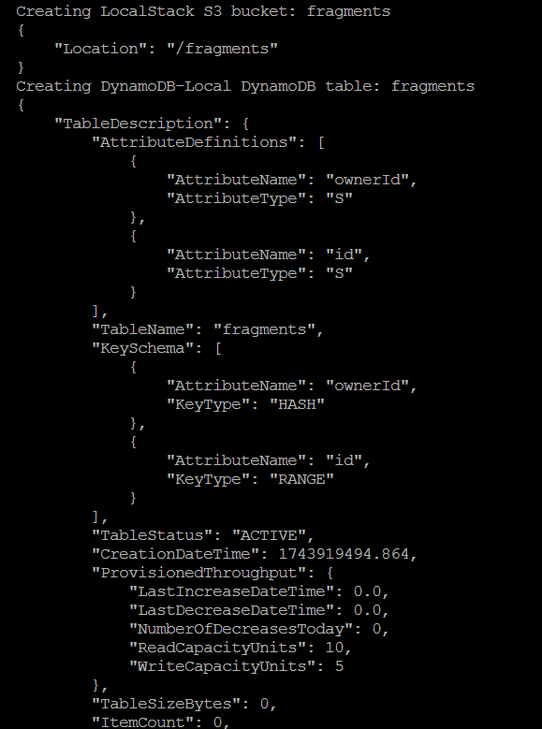
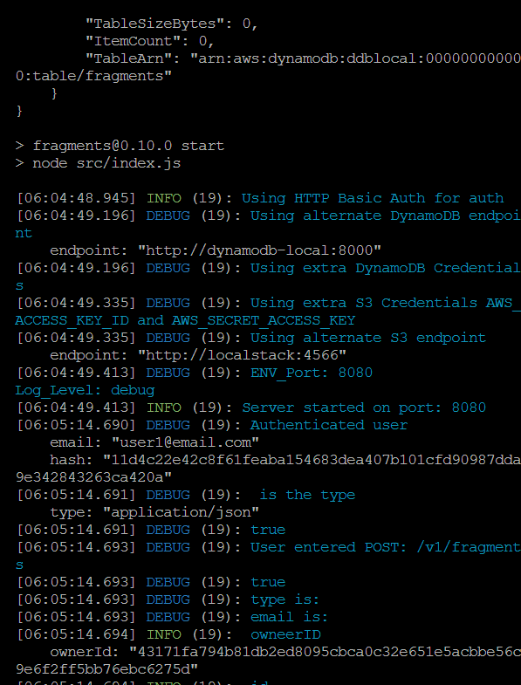
Make.Sh
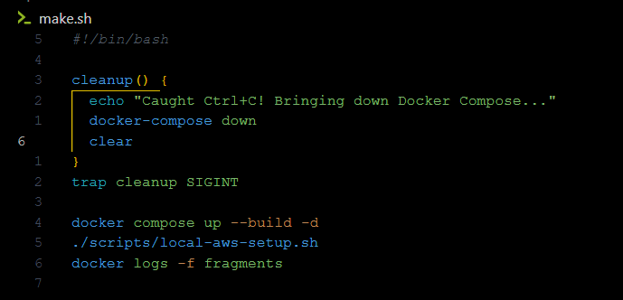

Against Server
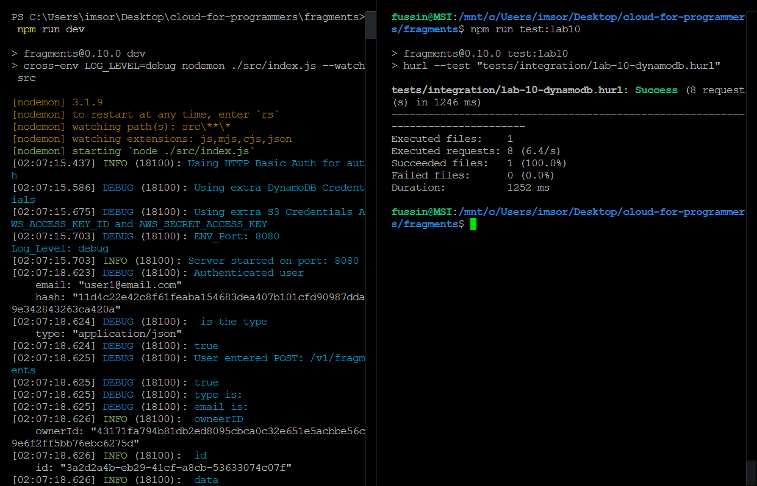

Screenshot of CI Everything Passing
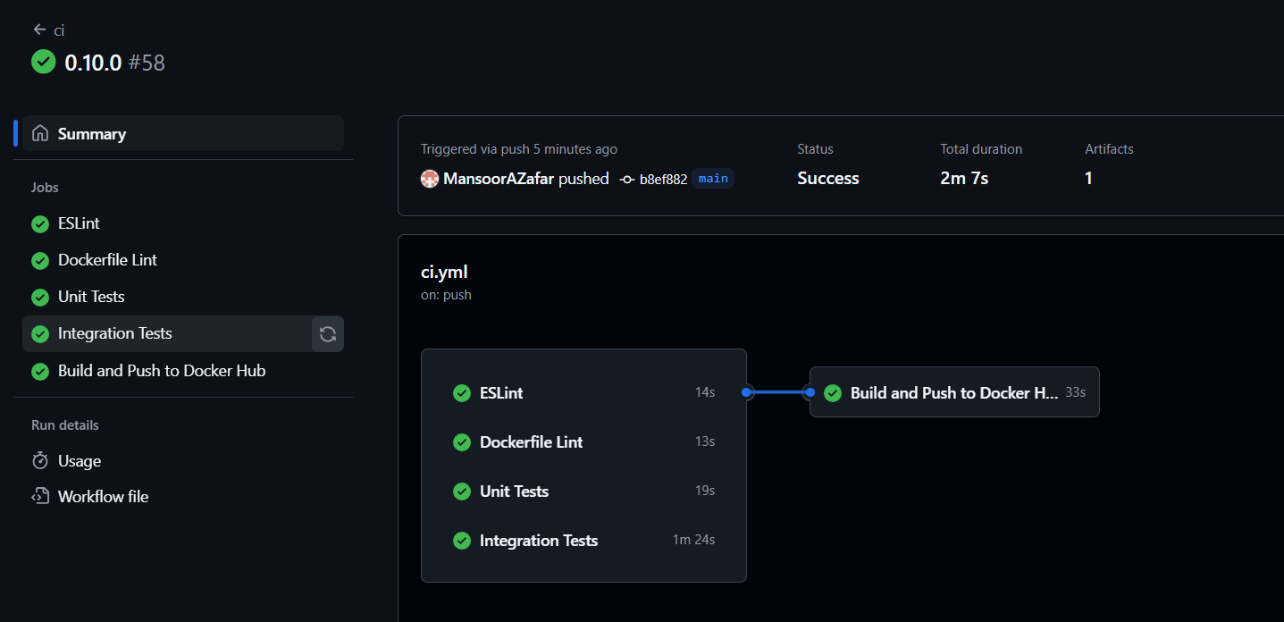

Screenshot of Fragments-UI creating Fragment with ECS
Creating Fragment
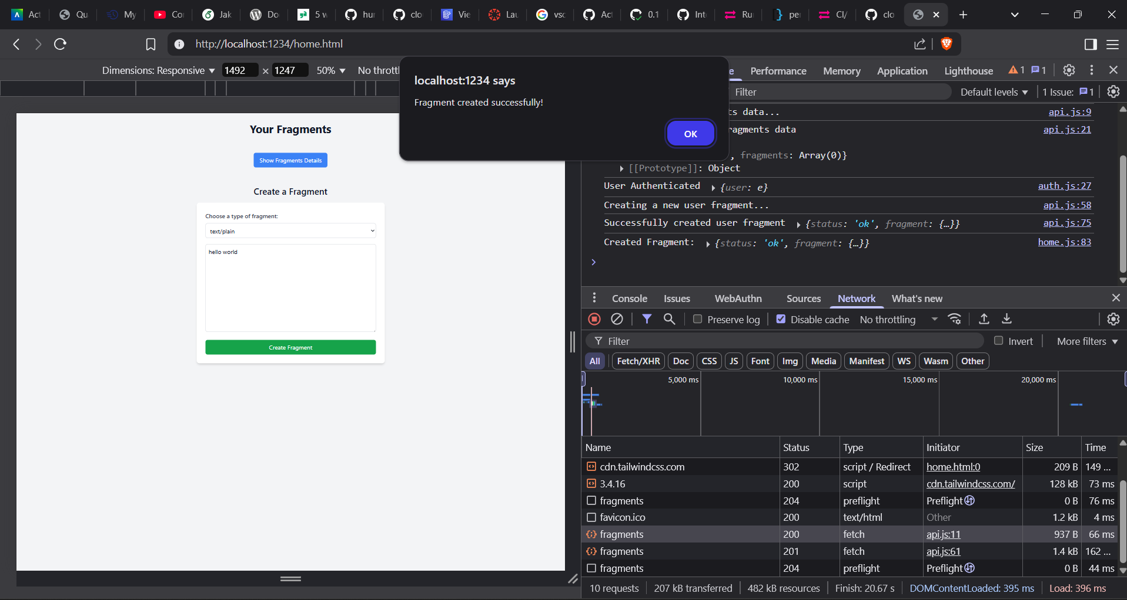
Fragment shown in Console (useful for when showing DynamoDB)

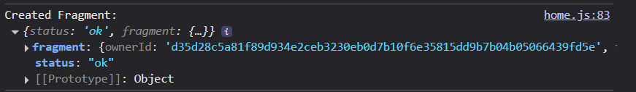
Network Tab proving backend-service is ECS
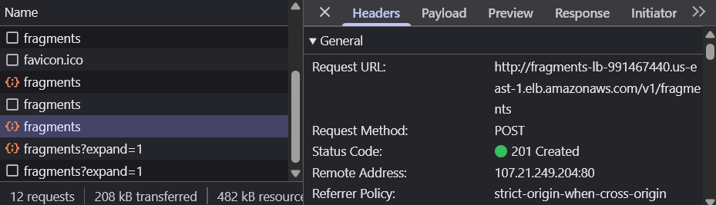
DynamoDB having item
